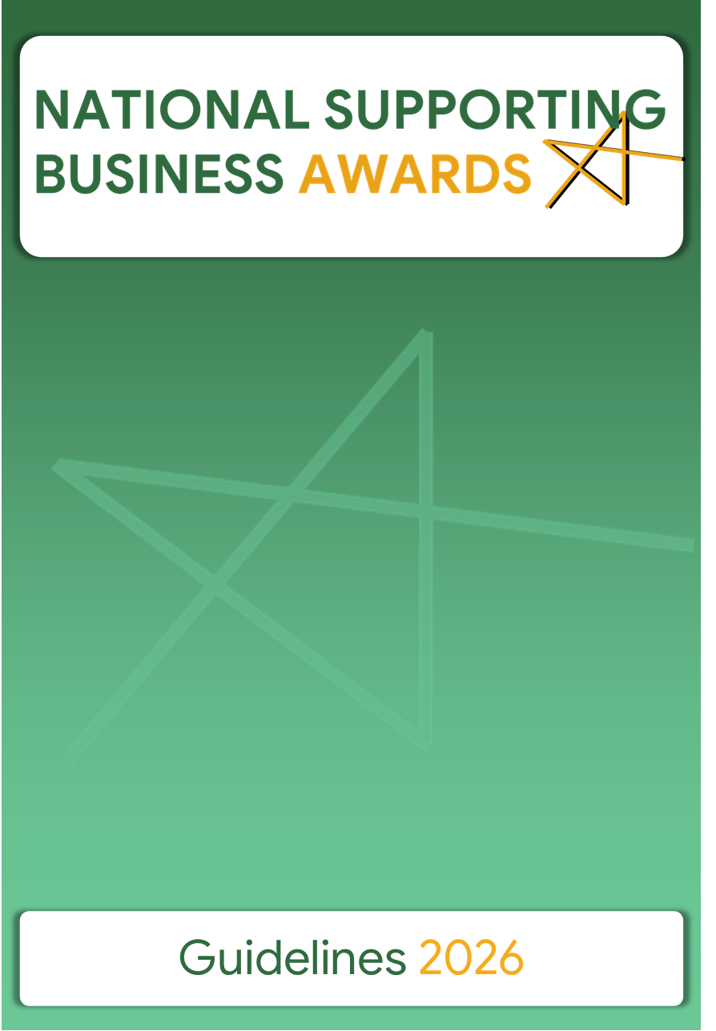

Contents

1. Definition and Rationale 2
1.1 An award that recognises excellence in promoting entrepreneurship 2
1.2 Objectives 2
1.3 The importance of entrepreneurship 2
1.4 Structure of the competition 2
1.5 Prizes 2
1.6 Prize money to charity 3
2. Methodology 3
2.1 Eligibility 3
2.2 Categories 3
2.3 Special Prize for Start-ups or young entrepreneurs 5
2.4 Evaluation Criteria 5
2.5 The Selection Committee 5
2.6 Submission of applications and deadline 6

1. Definition and Rationale

1.1 An award that recognises excellence in promoting entrepreneurship
The Commerce Department within the Ministry for the Economy, Enterprise and Strategic Projects has been organising this competition since 2010.

The aim of these awards is not only to create a competition but primarily to foster more awareness of the importance of entrepreneurship both on a local and on a national level.

1.2 Objectives
1. To identify and recognise successful activities and initiatives undertaken to promote enterprise and entrepreneurship;
2. To showcase and share examples of best entrepreneurship policies and practices;
3. To create a greater awareness of the role entrepreneurs play in society;
4. To encourage and inspire potential young entrepreneurs, and support start-ups.

1.3 The importance of entrepreneurship
Entrepreneurship-friendly policy is inherently linked to the needs of small and medium-sized enterprises (SMEs), a vital part of the European economy accounting for over 99% of European businesses. The SME sector contributes to innovation, is a source of competition, provides flexibility in the labour market and, most crucially, is a resource for job creation.

1.4 Structure of the competition
There are two different sections in this national competition - Section A and Section B (see Section 2.1).

Eligible participants may submit an application under more than one category provided that the project is different (see Section 2.2).

Although this competition is made up of two sections, the application form is common to both sections.

The submissions need to refer to recent initiatives that did not finish before 2021, and/or initiatives that have been ongoing for at least 12 months. These initiatives must have had influence on a local or national level.

1.5 Prizes
Winners from the two sections will receive a prize of €12,000 each and those who place second in the two sections will receive a prize of €7,000 each.

A maximum of 4 special mention prizes of €2,000 each may also be awarded.

As of this year a special prize of €4,000, may be awarded to a project that excels in the support to startups or young entrepreneurs (see Section 2.3).

The Selection Committee may refrain from awarding any one or more of the above prizes if the required level of the initiatives is not reached.

1.6 Prize money to charity
Any prize money awarded to Government Entities must be donated to a recognised charity. Each applicant must nominate three charities in order of preference. This ensures that the maximum number of charitable entities can benefit from the prize money allocated for these awards. This condition does not apply to Local Councils and to those who take part in Section B.

2. Methodology

2.1 Eligibility
Section A of this competition is open to Ministries, Departments, public authorities and entities, Local Councils and public-private partnerships.

Note: Public-private partnerships comprise the following:
- A financial agreement for which the private partner is charged with the implementation of a policy crafted by the public authority.
- An agreement between the private partner and the public authority for which the private partner is involved – due to its expertise, knowledge or resources – in the policy-making process; and
- An explicit support, not necessarily of a financial nature, that the public authority grants the private sector partner in the framework of a specific project.

Section B is open to NGOs, trade unions, professional associations, schools, educational institutions, the University of Malta, SMEs (under category 6 only) and associations representing sectors in business and industry.

As stated above, private entities which fall under the SME definition as set out in SME definition (europa.eu) are eligible to apply, provided that the project, which seeks to enter the competition is not the core business activity of the SME. The main factors determining whether an enterprise is an SME are:

1. staff headcount and
2. turnover or balance sheet total.

Initiatives which placed first or second in any past editions of the Awards cannot participate.

2.2 Categories
There are six categories in each section, and each category recognises initiatives that are successfully driving forward their enterprise performance:

Category 1: Improving the business environment and promoting the entrepreneurial spirit
This category recognises projects that promote an entrepreneurial mindset.
Example: Events and campaigns to promote entrepreneurship and a culture that encourages creativity, innovation and risk acceptance, along with measures to cut red-tape, get new businesses off the ground, support the transfer of business ownership, facilitate access to public procurement markets for SMEs.

Category 2: Investing in entrepreneurial skills
This category recognises initiatives at local or national level to improve entrepreneurial, managerial and employee skills.
Example: Promotion of specific skills such as technical skills needed in the craft and creative sector, language capabilities, computer literacy, mobility and mentoring schemes for entrepreneurs and entrepreneurship education in schools and universities.

Category 3: Supporting the digital transition
This category recognises initiatives which support the digital transition of enterprises enabling them to develop, market, and use digital technologies, products and services of any kind.
Example: Initiatives which help enterprises adopt digital technologies or bridge the digital gap.

Category 4: Supporting the internationalisation of business
This category recognises innovative policies and projects which help SMEs to expand to new markets, support cross-border trade and help to internationalise.
Example: Projects that support international business cooperation, information or match-making tools, support services or schemes that help SMEs go abroad.

Category 5: Supporting the sustainable transition
This category recognises policies and initiatives at national or local level that support the sustainable transition and environmental aspects such as the circular economy, climate neutrality, clean energy, resource efficiency or biodiversity through, for example, sustainable skills development and matchmaking as well as funding.
Examples: Initiatives which support the ecological transition and sustainable innovation.

Category 6: Responsible and inclusive entrepreneurship
This category recognises local or national initiatives by all entities mentioned in Sections A and B, and also SMEs that promote corporate social responsibility among small and medium-sized enterprises. This category also recognises efforts to promote entrepreneurship among disadvantaged groups such as the unemployed (especially long-term unemployed), legal migrants, disabled persons or people from ethnic minorities.
Examples: Social or non-profit enterprises serving societal needs through entrepreneurship.
NOTE: In agreement with the applicant, the Selection Committee may place an application in a different category from that originally applied for.

2.3 Special Prize for Start-ups or young entrepreneurs
As from this year, a special prize will be awarded to a project that excels in the support to startups or young entrepreneurs. The prize is inspired by the EU Startup and Scaleup Strategy.

The criteria for this prize will be based on the Strategy’s five core objectives:
• fostering an innovation friendly business environment,
• improving access to finance for startups and scale ups,
• supporting market entry and scale up,
• attracting and retaining entrepreneurial talent,
• facilitating access to networks, infrastructure and ecosystems.

2.4 Evaluation Criteria
Once an application is considered eligible to participate, it will be adjudicated according to the following criteria:

Criteria | Maximum marks
Originality and feasibility:  - Was the initiative original and innovative?  - Why is it considered successful? | 20 points
Impact upon the local economy:  - What was the impact of the initiative on the local economy?  - Did it create jobs?  - Is the initiative sustainable in the future?  - What positive long-term effect will it have? | 30 points
Improvement of local stakeholder relations:  - Was the local population involved in the initiative?  - Did the disadvantaged communities benefit?  - Were local cultural, environmental, and social characteristics respected? | 25 points
Transferability:  - Could the approach be repeated elsewhere in Malta?  - Could the approach be repeated elsewhere around Europe?  - Is the initiative inspiring to others?  - Are there any relationships/partnerships being developed to share lessons learnt? | 25 points

2.5 The Selection Committee
The Selection Committee will disqualify any application if it is not eligible for these awards.

The decision of the Selection Committee is final.

2.6 Submission of applications and deadline

Completed and signed applications can be sent either by

Post | Selection Committee (Attn: Mark Xerri)  National Supporting Business Awards 2026  Commerce Department  Lascaris Bastions, Daħlet Ġnien is-Sultan  Valletta VLT 1933
Or
Email | nsba.commerce@gov.mt
Deadline Applications must reach the Commerce Department by not later
than Friday 17 July 2026

https://commission.europa.eu/news-and-media/news/choose-europe-your-startup-and-scaleup-2025-05-28_en

