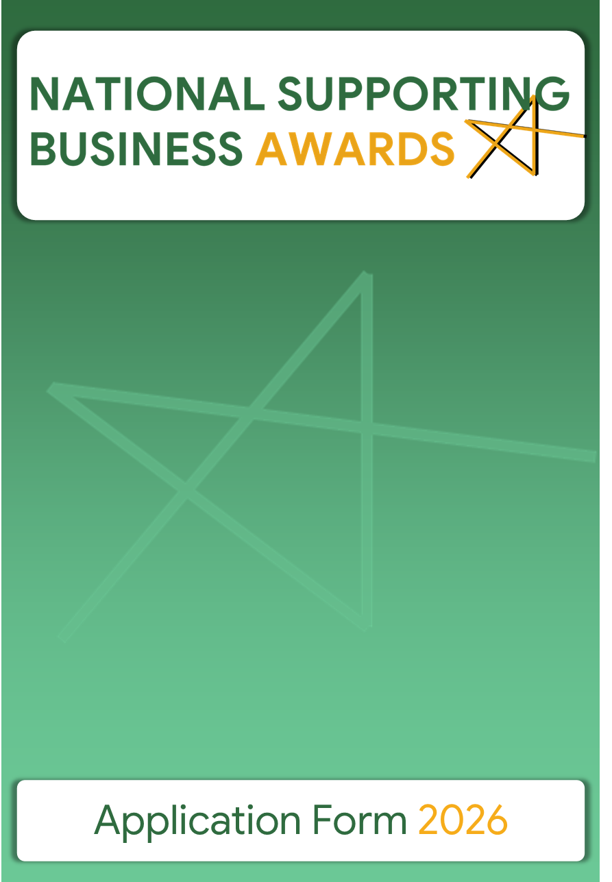

Part A – General Information

Title of the Initiative
Name of Participating Organisation
Section in which the Organisation is competing
Choose between Section A and Section B and tick one of the options under the chosen section as applicable
Section A⃰
 | Ministry |  | Department
 | Public Authority or Entity |  | Local Council
 | Public-Private Partnership |  | Other eligible Public Entity
Section B
 | School |  | Educational Institution
 | University Faculty/Institute |  | NGO
 | Professional Association |  | Trade Union
 | Association/Organisation representing sectors in business and industry |  | SME (eligible only under Category 6 – see Part B1 below)

Organisation’s Postal Address
Organisation’s Email Address
Organisation’s Website
Name of Contact person and Title
Contact person’s telephone
Contact person’s email address

Brief description of the Organisation and its remit (max 100 words)

Any prize money awarded to Government Entities must be donated to a recognised charity.

This condition does not apply to Local Councils and to those entities participating under Section B.

Part B: Details of the Initiative
The submissions need to refer to recent initiatives that did not finish before 2021 and/or initiatives that have been ongoing for at least 12 months. These initiatives must have had influence on a local or national level.

B1 - Category under which the Initiative is to be considered
You may apply under only one category per project. To submit projects in other categories, please fill in separate application forms for each project. In agreement with the applicant, the Selection Committee may change the category if deemed necessary.
For more details on each category, kindly consult Guidelines – Section 2.2
1 – Improving the business environment and promoting the entrepreneurial spirit
2 - Investing in entrepreneurial skills
3 - Supporting the digital transition
4 - Supporting the internationalisation of business
5 - Supporting the sustainable transition
6 - Responsible and Inclusive entrepreneurship

B2 - Public Private Partnership (to be filled in only if the project is an initiative between a public entity and a private entity)
If applicable, list all the public and private sector organisations involved in the initiative.
Specify whether the Partnership agreement is:
A financial agreement | Yes |  | No
A formal agreement | Yes |  | No
An explicit support | Yes |  | No
Details of the Public Private Partnership

B3 – Duration of the Initiative (minimum 12 months and did not end before 2021)
Start Date
End Date
Note: In the event that the initiative is still in progress, please write ongoing in the ‘end date’ box.
B4 – Budget
Indicate the overall budget invested in this initiative.
Separate and list the budgetary items covering the project.

Did the Initiative receive EU funding?
Yes |  | No
If yes
Specify amount
Specify type of funding

B5 – Description of the Initiative
Provide a detailed description of the initiative whilst addressing key points such as: providing a situation analysis, outlining the challenges, describing the creative solution, business strategy, implementation, stakeholders’ involvement and the future implementation plan of this initiative. Furthermore, outline the impact of this initiative on the local economy, local stakeholder involvement, and the transferability of this initiative (refer to Evaluation Criteria in Section 2.4 of the Guidelines).
Maximum of 500 words

B6 – Results of the Initiative
Provide detailed facts and figures of the initiative. These results must demonstrate that the initiative has existed for at least twelve months. They should include any measurable outcomes as well as statistical and comparative data.
Maximum of 500 words

B7 – Innovation of the Initiative
Explain what is innovative and successful about this initiative.
Maximum of 500 words
B8 – Attached Material and Links (not obligatory)
You may include links and/or visual and/or audio-visual material that promote your initiative. This material will help the Selection Committee to better understand your entry and may also be used for promotional purposes.

Part C – Promotion

C1 – Summary of the Initiative
Write a summary of approximately 350 words. This could be used as script for a videoclip if your initiative is shortlisted.

Part D – Charity organisations

Kindly indicate, in order of preference, three Charity organisations which will benefit in case of winning. This is only applicable to Public Entities participating in Section A.
1.
2.
3.

Part E – Agreement with the Applicant
As legal representative(s) for this initiative, I/we agree that the initiative may be submitted for entry in the “National Supporting Business Awards 2026”.

I/we declare that the material submitted in the application is a true and correct reflection of this initiative.

Name/s of Legal Representative/s
Title
Signature
Date (DD/MM/YYYY)
Note: By completing this Application Form, applicants give their consent to the processing of personal data to the extent necessary for the achievement of the purposes mentioned.

All personal data is collected and processed in accordance with the General Data Protection Regulation 2016/679 and all current Data Protection legislation and the Data Protection Policy of the Commerce Department which can be found on www.commerce.gov.mt.

Part F - Contact Details and Information
Completed and signed applications can be sent either by:
Post | Selection Committee (Attn: Mark Xerri)  National Supporting Business Awards 2026  Commerce Department  Lascaris Bastions, Daħlet Ġnien is-Sultan  Valletta VLT 1933
or
Email | nsba.commerce@gov.mt
Deadline to submit Applications:
Applications must reach the Commerce Department by not later than Friday 17th July 2026

For more information about the eligibility criteria, regulations, evaluation criteria, and prizes, please refer to the Guidelines of the Competition.

